**Question 1: what did you do?**

I used “ShieldsUP*”* to run two scans by the common ports and the all service ports options.

**Question 2: what were the results?**

My computer system and Internet passed these two scans, which is the system and Internet is secure.

**Question 3: what did you learn**?

“ShieldsUP” is a great website to run scans for computer system and Internet on daily basis for making sure system is safe and Internet is secure. I always used Internet on my own laptop in hotel, restaurants, coffee shops, airports while I was on trip every time. Additionally, I used Wells Fargo own computer and Internet access for working. IT team did not do great job to clean, my office computer system and Internet always slow, screen freezing, was down in middle business processing. Thank to Dr. Jennex introduced the website, I will start to use it daily basis to make sure system and Internet are always secure.

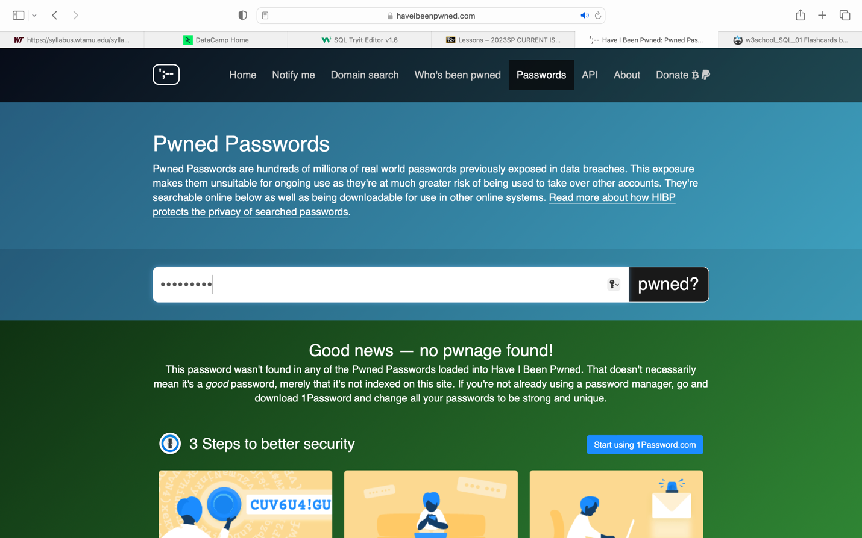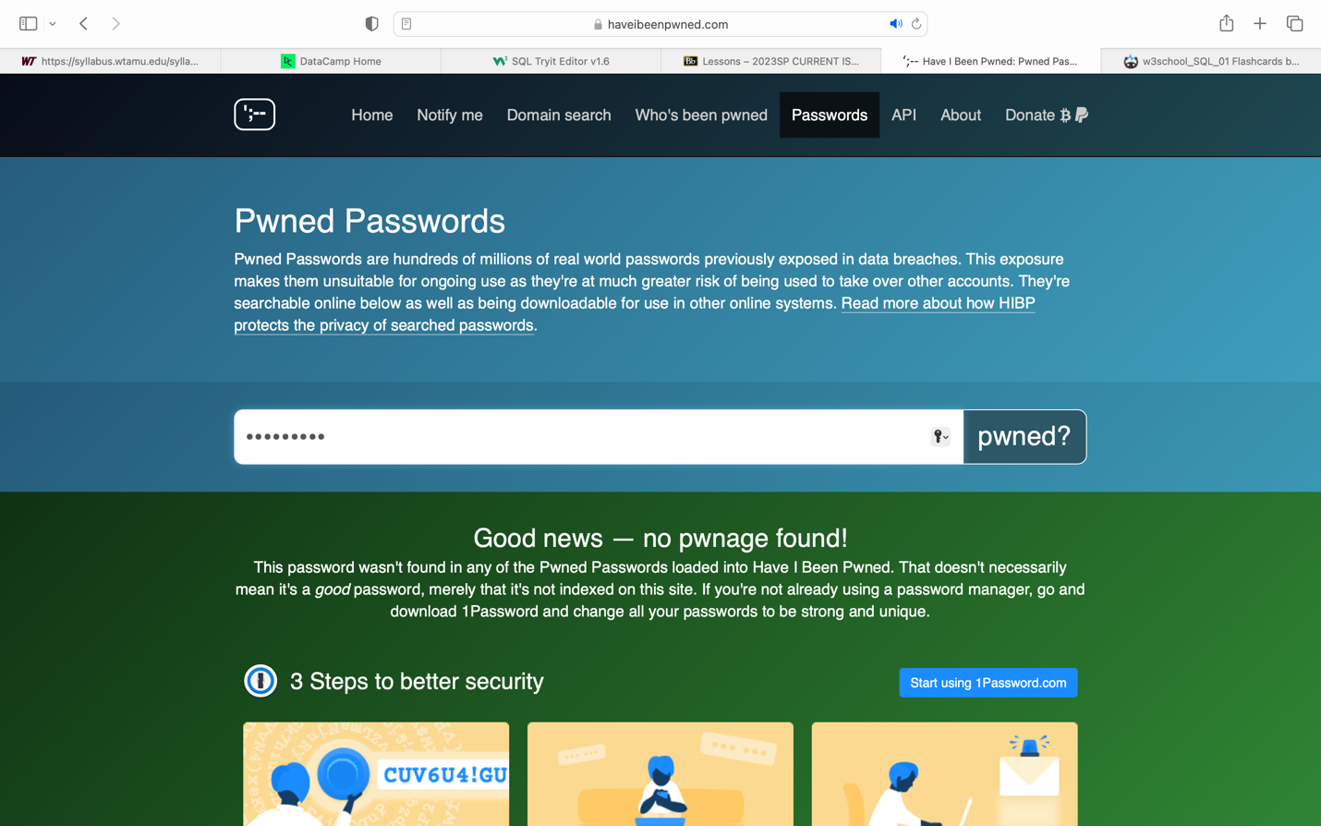

**Question 1: what did you do?**

I used “Have I been pwned?” to check my Email addresses, phone number, all my passwords if they have been disclosed.

**Question 2: what were the results?**

No pwnage found from my Email addresses, phone number, all passwords.

**Question 3: what did you learn**?

“Have I been pwned?” is a great website to check Email address, phone number, all passwords if they have been disclosed. Personal information is the most important to protect to avoid hackers damage your life, even life threat. Cybercrime increases since Covid-19 hit hard in 2020. Scam, fraud are the most common issues while I was a banker in Wells Fargo. Some my customers had such issues, for example, romance scam is common issue to lose banking information, my customers became victims from it, I usually contracted Wells Fargo Investigation team and FBI financial crime unit from Austin office to file reports. Such cases usually take two or three months to solve it. Fraud is other common issue in banking industry. In the past, someone was lying to be a Wells Fargo employee to stole customer information by calling exist Wells Fargo customers. Finally, these customers suffered from losing entire personal and banking information. Wells Fargo and FBI had to spend months to solve the case. Thank to Dr. Jennex introduced the website to check my Email address, phone number, all passwords are still secure.